03/20/2025
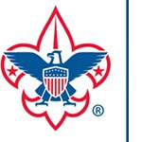

Boy Scouts of America Tuscarora Council
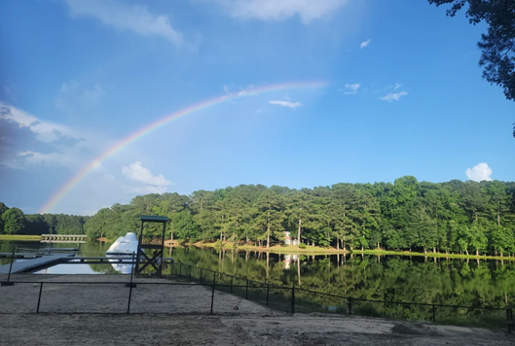

Strategic Plan 2025-2030

Tuscarora Council
172 NC Hwy. 581 South – Goldsboro, nC 27530

What is the desired outcome?
Provide the Tuscarora Council with a roadmap to serve as a short and longer-term guide to action. This document identifies the council strategic thinking to allow us to continue building on our past, while constantly looking forward and addressing new challenges in order to strengthen the Scouting program in our four-county area.

Mission Statement
The mission of the Boy Scouts of America is to prepare young people to make ethical and moral choices over their lifetimes by instilling in them the values of the Scout Oath and Law.

Vision Statement
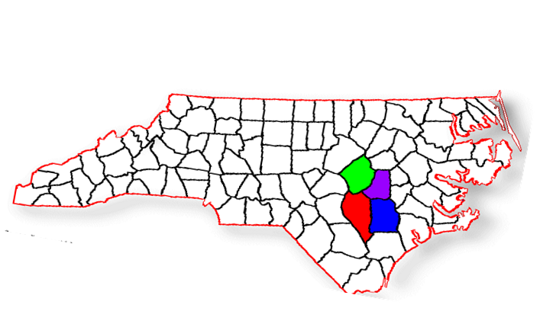
The Boy Scouts of America will prepare every eligible youth in America to become a responsible, participating citizen and leader who is guided by the Scout Oath and Law.

Tuscarora Council

Who We serve -








Youth Units Community






Volunteers Donors Employees



2025 – 2030
Strategic Plan



Membership & Recruiting
Increase Scouting’s reach and influence throughout the Tuscarora Council’s four county area through a focused, sustainable membership growth plan. Simply relying on a yearly fall Roundup season is not sufficient nor viable to allow every available youth the opportunity to join Scouting.

- Encourage and train units to more fully and effectively participate in year-round Pack membership growth as well as program driven retention.
- Recruit, develop and train new member coordinators for every Pack.
- Establish strong, effective and active District Membership Committees.
- Develop a unit assessment initiative.
- Maintain strong working relationships with our local School Superintendents.

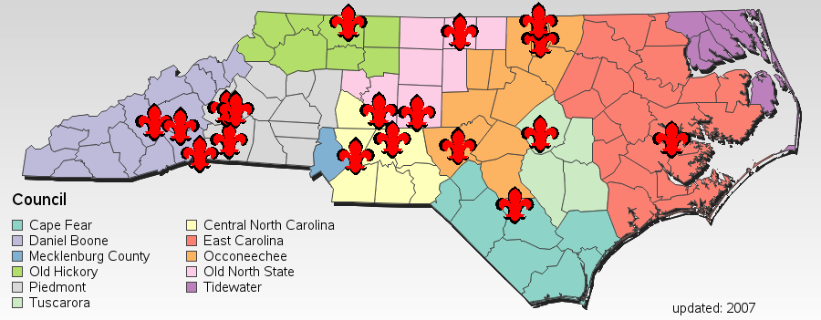

Camping & Program
Provide Scouts a chance to learn, grow, build fitness and have fun in a safe outdoor environment. The activities provided should deliver adventure, challenge, teamwork, confidence building including new and exciting locations. Developing Cub Resident and Boy Scout Summer Camp long term sustainability.

- Increase the volunteer leadership base for council programs and outdoor activities.
- Increased experienced adult summer camp leadership staff.
- Strengthen Scouts summer participation through expanded summer programs, opportunities and adventures both on and off camp property.
- Support and grow outside group usage of Camp Tuscarora.



Marketing and Communications
Develop an effective online presence to present the council, units and activities in a way that helps people make informed decisions on Scouting. Ensure our council website and social media contains the most current information, pictures and videos for volunteers, prospective Scouts and families to gather information.

- Develop and institute a robust social media campaign.
- Increased marketing interaction with units, districts and volunteers.
- Increase Camp Tuscarora’s visibility to our councils’ communities.
- Recruit, develop and train district social media chairmen and committees.



Financial Growth
Work to increase council revenue to ensure the Tuscarora Council’s future financial stability.

- Increase our council FOS donor base with new individuals, corporations and foundations.
- Develop a strong DCAD committee of past recipients in the Neusiok District.
- Increase total direct support of the operating fund to $1,000,000 annually to provide for a council Program Director Position.
- Increase our Endowment Fund assets by $2 million, by 2030.

A Message: The Years Between

Long range planning is an essential part of ensuring the council’s success moving forward. Without the foresight of those wise leaders years ago we would not be where we are today. It is incumbent upon us to continue the rich tradition of providing a path to where we would like the council and Scouting to be in the future. As a reminder, these are the writings of Dick Auger from 1972.

Seven years ago, under the leadership of Dr. Ashton Griffin, A long range planning committee was established to examine our past, present and future. Coming out of this study were certain major goals to be achieved. High on the priority scale was the addition of two more professionals. Next it was found that the camp facilities of the council were inadequate, and the future expansion was essential if we were to continue in the camping business. Also, office facilities were found inadequate. To begin with a public relations campaign was necessary to let the people of Wayne, Johnston, Duplin and Sampson Counties know what was going on in the Scouting program. Dick Moffatt fostered the long-range plan and vowed to spear-head a Capital Fund Campaign to develop camping facilities.

